**Build an employee travel approval application for corporates**

**INTRODUCTION**

• Overview Corporate travel is an integral part of the business world, as companies need to travel to meet clients, attend conferences and meetings, and explore new markets. However, managing employee travel can be a cumbersome task for the HR and travel departments. That's why many corporates have started using employee travel approval applications to streamline the process.

Here’s how you can create and streamline your travel request approval workflow:

STEP 1: Set goals

First, identify and define the goals of your travel request approval workflow. Ensure all the stakeholders involved in the process are familiar with the new workflow and are on the same page.

STEP 2: Create a travel and expense approval process workflow

The next ideal step after you set your goal is to create an expense and travel approval process. Ensure you create all the steps employees must follow to receive the advance fund.

STEP 3: Specify mandatory information

The finance department in your firm will receive hundreds of approval requests daily. This means while going through these requests, the finance department might miss out on flagging requests that violate policies set by the firm.

That is why employees must mention only important information about expenses while requesting funds. This way, the approvers can quickly glance through the requests, and the finance team will know whether they should approve or reject them.

Here are some of the common line items that can be used in the request approval form:

Trip purpose

Duration of the trip

Which location is the employee traveling to?

Breakdown of expenses

Extra cost

STEP 4: Set permissions

The next important thing to do is after creating the workflow is to assign stakeholders in each stage and set different levels of permission. In this step, define the roles and responsibilities for individuals based on their tasks. Also, according to the grade, define the responsibilities of the approving manager in the travel request workflow.

STEP 5: Implementation

After setting up goals, permissions and workflow, you should then implement the approval workflow process in your organization. After implementing the approval workflow process, employees can now initiate travel requests and the head of departments can approve them.

STEP 6: Improve the existing workflow

## After the existing system works for a while, you will have enough insights to make the approval process faster and more efficient. Using these data, you can find the average approval time. The time employees take to file and other important information.

**Purpose**

The application saves time for both the employee and the travel manager by automating the travel request and approval process. The application ensures that travel requests comply with the company's travel policies, which reduces the risk of non- compliant expenses and unnecessary travel.

**CREATING THE APPLICATION**

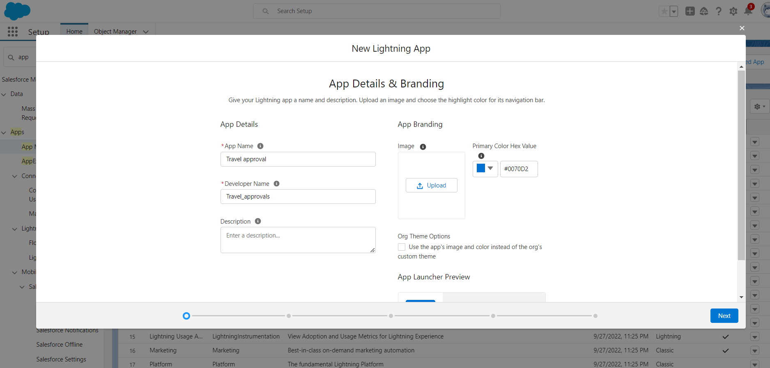

**CUSTOM OBJECT CREATION**

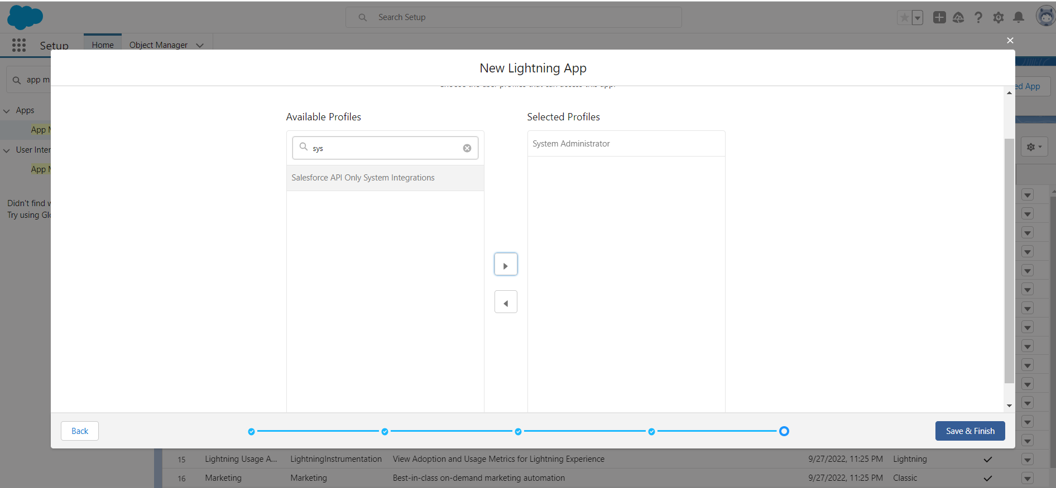

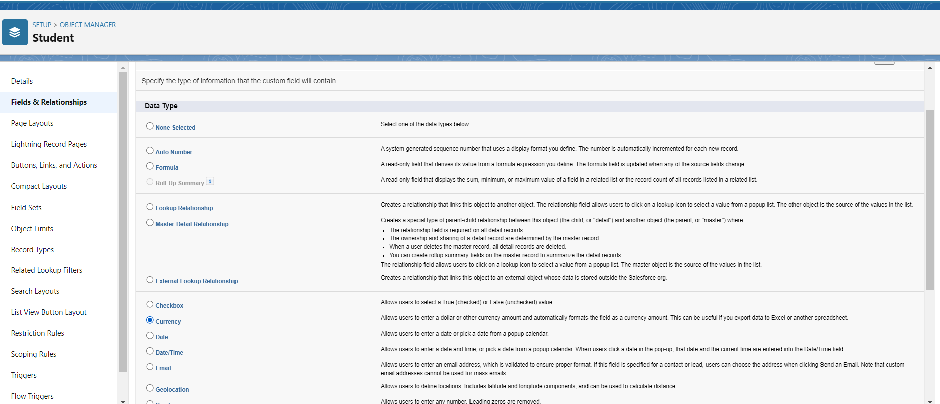

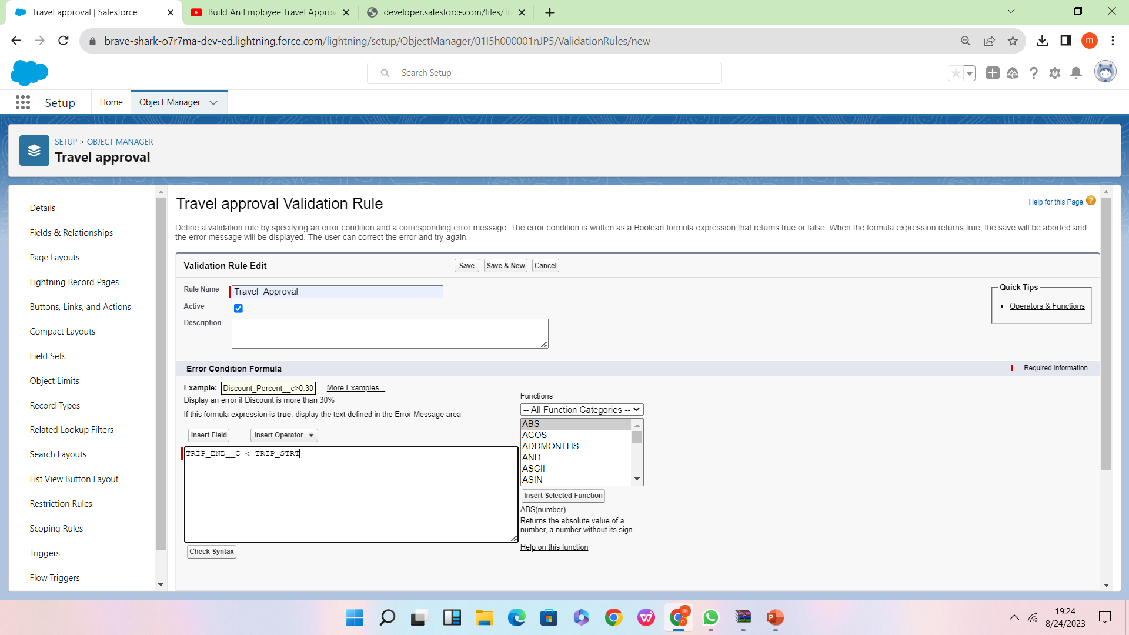

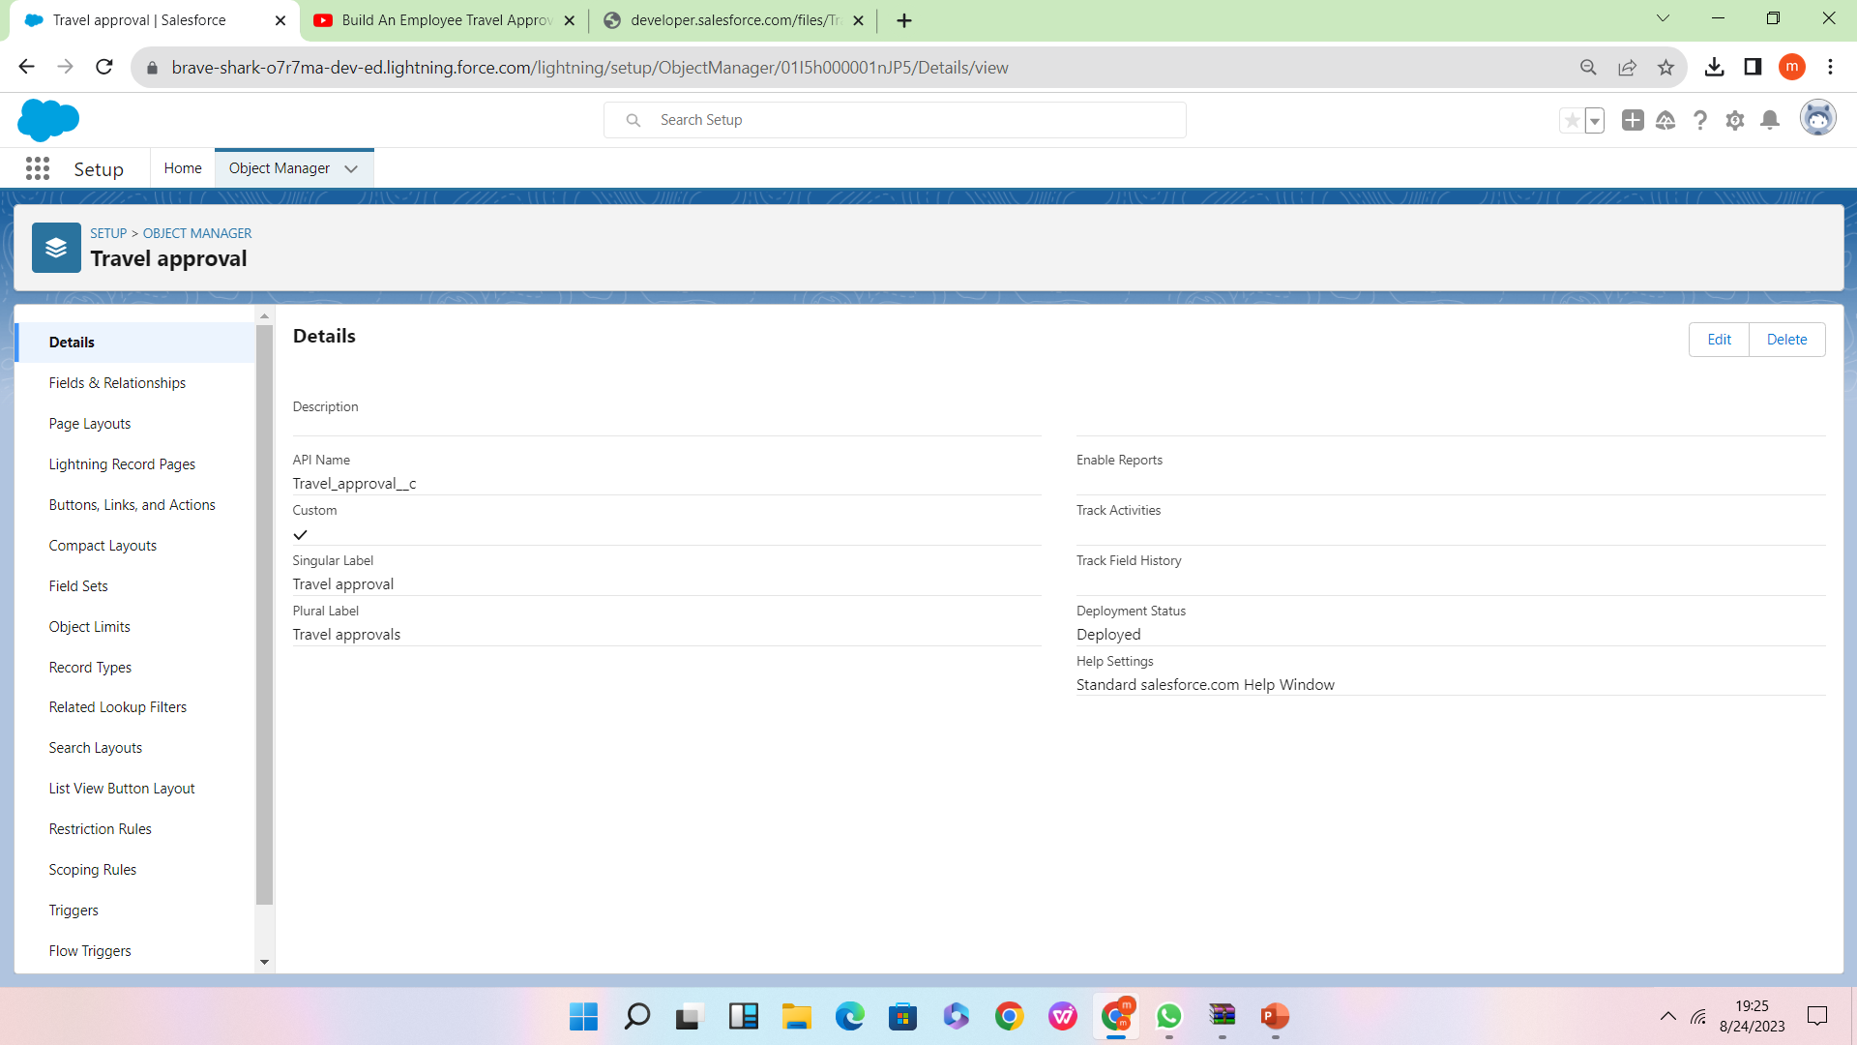

**Advantages**

1. The process is tedious andtime-consuming task
2. b. Easiest way
3. c. Saves time for both employees and managers
4. d. Reduces the workload
5. e. The entire process is digitized and streamlined
6. f. Increased Transparencyg. Provides greater control and security over employee travel

1. Approvals on time

The entire process of planning and managing a trip is a long and stressful process. This means your employees need to spend hours looking for travel options,  By automating the approval workflow, you can simplify the process. Your employees no longer have to run behind a manager or finance team for approvers.

2. Customize approval workflows

The approval process can differ from company to company. Using expense management software, you can customize the workflow based on your organization. You can set up multiple workflows within your organization, that will allow you to better manage your expense approval requests.

3. Increase compliance and reduce costs

A well-defined [expense approval workflow](https://blog.happay.com/expense-approval-process/" \t "https://happay.com/blog/travel-request-approval-workflow/_blank) will help in reducing non-policy-compliant expenses in your firm. You can now prevent expense frauds such as duplicate bills, overstated expenses, non-policy complaint items, manipulated invoices, etc.

4. Faster process

Most expense management software comes with mobile capabilities. This means approvers get notified of the travel requests sent by employees, which they can approve or reject fast. This reduces approval time and enhances the expense management process in your firm.

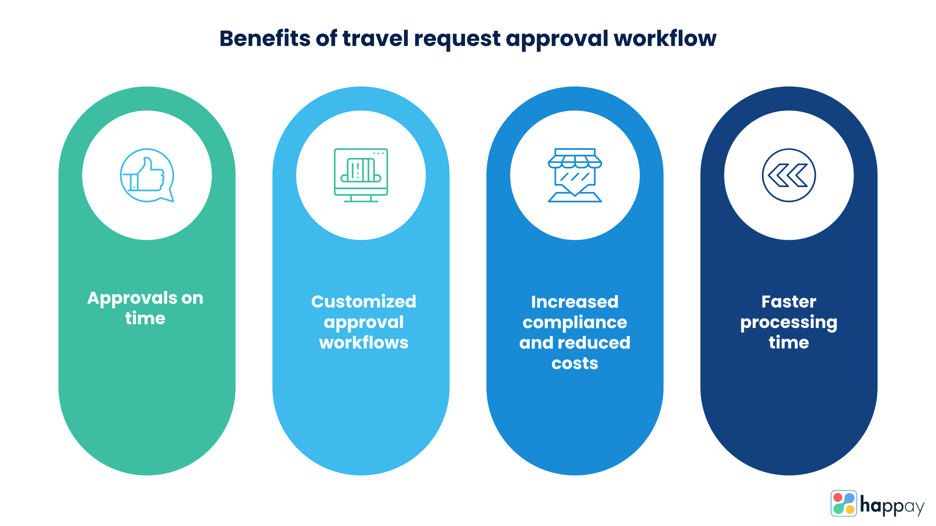

**DISADVANTAGES**

1. The process includes too manylevels of approval that maketedious and confusing
2. b. Regular Maintenance
3. c. Internet Connection problemis there
4. d. Poor Connection leads totrouble and anxiety
5. e. Lack of leadership
6. f. It can be costly sometimes
7. g. Poor communication

**APPLICATIONS**

The application ensures that travel requests comply with the company's travel policies which reduces the risk of non-complaint expenses and unnecessary travel. The application helps reduce travel costs by allowing the company to track expenses and stay within budget. This also helps the company negotiate better deals with travel vendors. The application saves time for both the employee and the travel manager by automating the travel request and approval process. This allows the HR department and travel managers to focus on more strategic tasks.

**Conclusion**

An employee travel approval application is a valuable tool for corporate travel management. It streamlines the travel request and approval process ensures policy compliance, and provides transparency to all parties involved. A well-designed application can save time and money, making it an essential tool for corporate that frequently travel for business.

**FUTURE SCOPE**

In future it will be really a useful one in the application of travel approval.b. It is trusted to be in future everyone will utilize this.c. The customer will set good service and make it trustworthy.d. Hope it would fulfil all the needs of the users.

**THANK YOU**

DAYYALA DURGA GANESHGUDIYA TARUN SAHUBAINAPALLI JAGADEESHMEDASANI CHATHURYA